**Spatial Distribution Prediction Ground Water Quality in Mosul City/ Iraq Using Variogram Equations**

1Mus'ab A. Al-Tamir and 2Abdullah I. Ibrahim

University of Mosul, College of Engineering, Environmental Engineering Department, Mosul-Iraq

**Supplementary Information**

**Table S1: Descriptive Statistics for Selected Groundwater Parameters**

|  |  |  |  |  |  |  |  |  |  |
| --- | --- | --- | --- | --- | --- | --- | --- | --- | --- |
| Variable | N | Mean | SEMean | StDev | Minimum | Median | Maximum | Skewness | Kurtosis |
| Temp_Original Data Set | 30 | 19.8 | 0.334 | 1.827 | 17 | 20 | 23 | 0.14 | -1.11 |
| Temp_Log transformed | 30 | 1.2949 | 0.00732 | 0.0401 | 1.2304 | 1.301 | 1.3617 | **0.01** | -1.13 |
| Ttemp_EX transformed | 30 | 1549 | 467945610 | 2563043664 | 24154953 | 485165195 | 9744803446 | 2.4 | 5.68 |
| Temp_SR transformed | 30 | 4.4451 | 0.0375 | 0.2051 | 4.1231 | 4.4721 | 4.7958 | 0.07 | -1.12 |
| pH_Original Data Set | 30 | 7.0433 | 0.0522 | 0.2861 | 6.6 | 7 | 7.8 | 0.55 | 0.47 |
| pH_Log transformed | 30 | 0.84744 | 0.00319 | 0.01749 | 0.81954 | 0.8451 | 0.89209 | **0.43** | 0.26 |
| pH_EX transformed | 30 | 1193.8 | 68.5 | 375 | 735.1 | 1096.6 | 2440.6 | 1.5 | 3.29 |
| pH_SR transformed | 30 | 2.6534 | 0.0098 | 0.0537 | 2.569 | 2.6458 | 2.7928 | 0.49 | 0.36 |
| EC_Original Data Set | 30 | 2426 | 183 | 1000 | 1150 | 2250 | 5000 | 0.73 | -0.23 |
| EC_Log transformed | 30 | 3.3501 | 0.0322 | 0.1762 | 3.0607 | 3.3521 | 3.699 | **0.16** | -1.15 |
| EC_SR transformed | 30 | 48.28 | 1.81 | 9.9 | 33.91 | 47.43 | 70.71 | 0.43 | -0.84 |

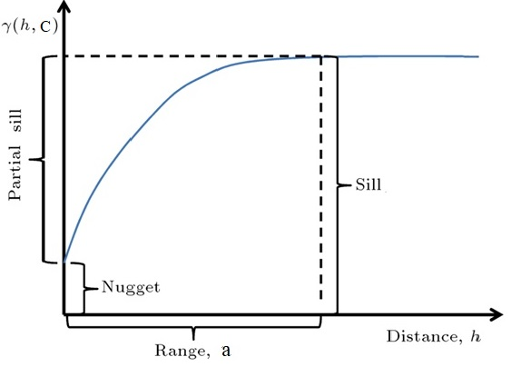

**Figure S1: Typical Simevariogram model components.**

Where:

(h) represents lag distance.

(a) represents (practical) range

(c) represents sill.

**Table S2: The Semivariogram models that applied in current study**

|  |  |
| --- | --- |
| Model Name | Semivariogram Model Equation |
| 1. Circular |  |
| 2. Tetraspherical |  |
| 3. Pentaspherical |  |
| 4. Exponential |  |
| 5. Gausian |  |
| 6. Rational |  |
| 7. Quadratic |  |
| 8. Hole effect |  |
| 9. K-Bessel | In which Ωθk is a value found numericall so that ɣ(h)-0.95(C0+C) for any θk, 𝚪(θk)Is the gamma function10, $$Γ\left(y\right)= \int_{0}^{∞}{xy^{-1}\exp\left(-x\right)dx}$$ And Kθk is the modified Bessel function of the second kind order θk |
| 10. J-Bessel | In which (C0+C)≥0, a≥0, θ≥0, Ωθd must satisfy B=a, B>0, ɣ(B)=C0+C, ɣ’(B)<0, and Jθd is the J-Bessel function; and stable, $$γ\left(h,C\right)=C_{0}+C\left[1-e^{\left(-3{\left(\frac{h}{a}\right)}^{θ_{e}}\right)}\right], for all h$$ In which C0+C and 0≤θ≤2 |
| 11. Stable | $$γ\left(h,C\right)=C_{0}+C\left[1-e^{\left(-{\left(\frac{h}{a}\right)}^{∝}\right)}\right], for all h$$ 0<α<2 |